PHYSICS 536

Experiment 11: IC OP-Amp and Negative Feedback

In this experiment you will measure the properties of an IC op-amp, compare the open-loop and closed-loop gain, observe deterioration of performance when the loop gain is not large, and observe the basic amplifiers (inverting, non-inverting, and follower). Please remember to compare your observed and expected values.

1. DC Characteristics. The DC output voltage is determined by the input currents ( and ), the input off-set voltage (), and the feedback resistors ().
(13.88)
When is sensitive only to the difference between the input currents, called the input off-set current, .

(13.89)
2. Closed-Loop Gain.
NON - INVERT:
(13.6, 13.10)
INVERTING:
(13.72)

(13.7)

The closed-loop gain is controlled by the feedback components when the loop-gain (AB) is large. Large loop-gain means that or . The quality of the amplifier is determined by the loop-gain, which becomes approximately one as the signal frequency (f) approaches the closed-loop break frequency ().
(13.17)

3. Effect of Quality Ratio on Input and Output Characteristics. When , the inverting input acts like a virtual ground, hence the signal () at that point is very small.

(13.72)

A is not much greater than unless , hence the virtual ground concept () is not valid when the signal frequency (f) is close to . The closed loop output resistance () also is very small when .
(13.80)

becomes approximately equal to the open-loop output resistance () when . Since the gain and output resistance are both frequency dependent, it is convenient to combine the two effects.
(not used on test) (13.83,13.84)

This equation shows that adding a small load () at the output of a feedback-amplifier has the same effect as reducing the break frequency (). has little effect when , but it can cause a substantial decrease in gain when .

4. The Slew Rate determines the maximum rate at which output voltage can change. The maximum amplitude that a sine wave can have without distortion is,

(12.57)

The 741 op-amp is a general purpose device with . It is fully compensated i.e., suitable for ). Set up the following circuit on the plug-in chassis. The op-amp should straddle the center space of the plug board. The two power pins (4 and 7) must be connected at the beginning, but the null circuit (pins 1 and 5) is not connected until step-5. The adjustable resistor is described on the last page of the general lab instructions. Adjust the power supplies for 15 volts before they are connected to the circuit. The op-amp will be destroyed if the power voltages exceed 18V. Turn off the power supply before you change components. The pins on the op-amp can be damaged when you pull it out of the circuit board.

Hold it at the ends or insert a small screwdriver under the op-amp to lift it from the board.
In some experiments it is sufficient to put by-pass capacitors at one end of the green and red power sockets. Op-amps may oscillate unless the by-pass capacitors are connected close to the DC voltage pins on the op-amp. Connect one end of a by-pass capacitor to the same row of sockets used for the op-amp pin (4 and 7). Connect the other end of the capacitor to ground.

A. DC Limitations
,, and will be adjusted in this part of the experiment to observe separately the effect of each of the input parameters. Table 4.1 in the text gives only the maximum values for and . The following typical values provided by the manufacturer should be used in calculations: , , and .
1) Calculate the expected value of for the resistor combinations given on the component sheet for steps 2,3, and 4. The term “meter” in the column is explained in step 3. You should check that they op-amp is working before beginning DC measurements. Apply a small, 100Hz sinusoidal signal at the input (A) and observe that an amplified sine wave appears at the output. Disconnect the signal generator before step 2.
2) Measurement. Measure and calculate . Why can be neglected in this measurement? Do not connect the null circuit until step 5.
3) Measurement. is replaced by the digital meter, which is set to record voltage. Connect a 0.1μf capacitor from pin 3 to ground to suppress noise generated by the digital meter at the input of the amplifier. The current goes into the + input and flows through a 10M resistor inside the meter to produce the measured voltage. (Refer to GI 2.2) Calculate using I=V (meter)/10M. Measure using the analog meter or the scope with the input connected for DC. Why is the effect of on minor in this arrangement?
4) I_{os} Measurement. Continue using the digital meter in place of . Insert equal 10M, observe , and calculate . Notice that is much smaller in step 4 than in step 3, although has3 not changed. Explain this observation. Remove the meter and 0.1μf capacitor from pin 3.
5) Null Adjustment. Connect the null circuit to pins 1 and 5. Make the connections specified for step 5A on the component sheet. Since the output is connected to and is zero, is equal to . Adjust the variable resistor until is . Next, change the gain to 1000 by using the 5B connections. Now a small maladjustment of will have much more effect on . Adjust the variable resistor to see how close you can get to zero. It should not be necessary to readjust the null because is satisfactory for the rest of this experiment.

B. AC Limitations
The non-inverting amplifier form will be used for all measurement except steps 17-20, i.e. the input signal () should be applied to point A.
6) Include in your laboratory report the calculated value of .
7) Measure at 1kHz with =1V. Compare and using dual trace to see that they are in phase.
8) Saturation limits. Increase until the peaks of are cut off by the amplitude limits. Report the observed saturation limits. The maximum output voltage should be approximately 1 volt smaller than the power supply voltages. Slew rate limits will be observed for square and sine waves.
9) Include in your laboratory report the following calculation. Given a positive slew-rate =1.5V/μsec and a negative slew-rate of –0.7V/μsec. Assume that the output signal is a 10V, 10kHz, “square” wave. Sketch showing time and voltage scale. Calculate the maximum amplitude hat a 20kHz sine wave can have without slew-rate distortion.
10) Initially use a 10V, 10kHz “square” wave for , the observed slew rates may be substantially slower than the estimates give in step 9. If necessary, reduce the square wave frequency until has a constant voltage period between the changes. Measure the positive and negative slew rate from the scope trace. Draw a sketch of .
11) Use a 20kHz sine wave to observe slew-rate distortion. Start with approximately 1V and increase the amplitude of the input signal (). You will notice that becomes distorted, looking more like a triangle than a sine wave. Compare the amplitude at which the distortion begins to that expected for the slew-rate observed in step 10.
12) limit. When the external load resistor () is small, the output voltage is limited by the current available from the op-amp, (max) = (max)RL. Use a 10Khz, V input signal. Connect a 100 ohm resistor from the output to ground. Measure the positive and negative limits on the output signal and calculate the output current limits.

C. Open-Loop and Closed-Loop Bode Plots

“Open-Loop” Bode Plot
It is practically impossible to measure the true open-loop gain of a high-gain op-amp. The low frequency gain is so high that the input noise causes large random variations at the output. The simplest way to reduce the low-frequency gain is to use negative feedback. Above the break frequency, the gain with feedback is approximately equal to the true open loop gain, as shown in the following sketch.

13) Include the following calculation in your laboratory report. Given = 1 MHz, calculate the break frequency .
14) Insert R1 and R2 in the circuit. Measure and the gain G1 at 0.1, 1, 10, and 100 times . Use these 4 points to draw G1 on log-log graph paper. Use the two high frequency points to draw A. Your plot will be like the one shown above, except your axes should be quantitative.

Closed-Loop Bode Plot.
Change R1.
15) Calculate the new closed-loop gain G2 and break frequency , assuming = 1 MHz. Include this in your laboratory report.
16) Measure G2 at mid frequency and measure . (Review GIL-5.6A) Don’t exceed the slew limit. Calculate from G2 and and compare it to the typical value of 1MHz. Use the measured value of G2 and to add this closed loop again to the Bode plot started in step 14. Show on the Bode plot. The final Bode plot should be similar to the following sketch.

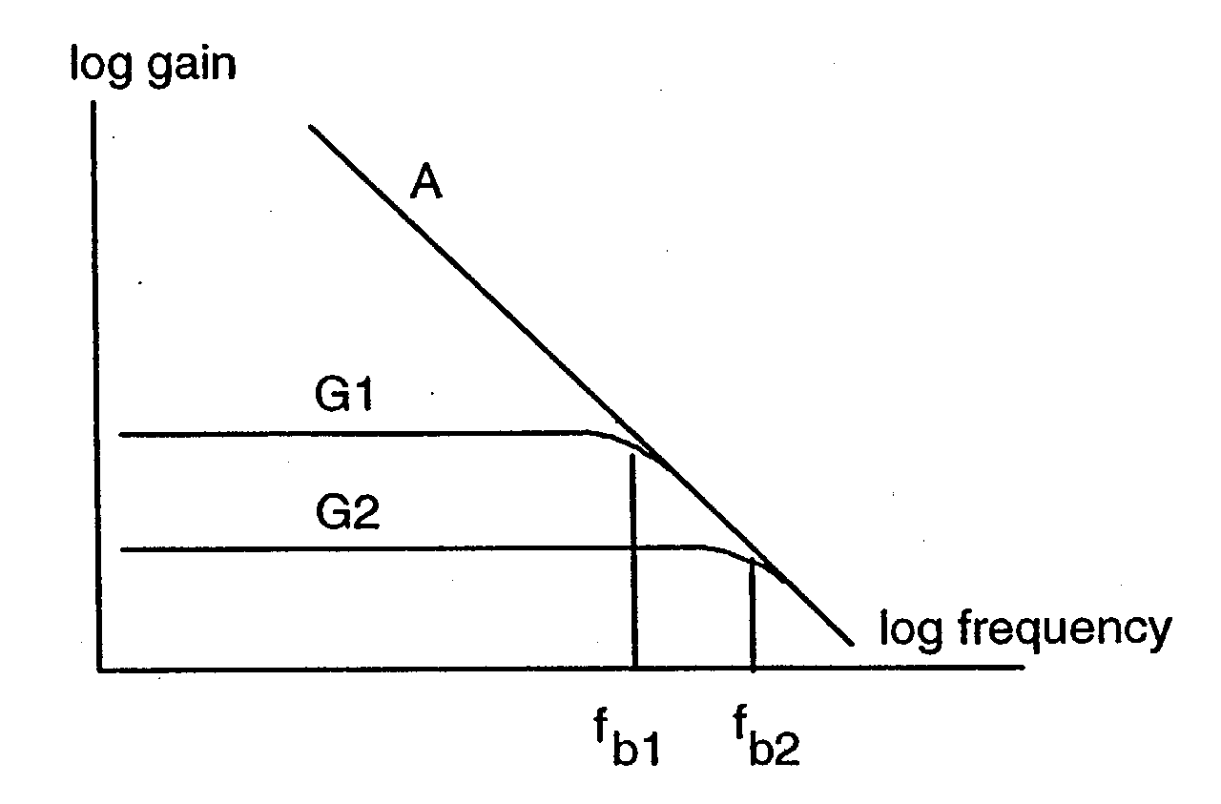

D. Dependence of Quality on A/.
It is inconvenient to observe the input resistance of the op-amp because it is rather high, even without feedback (typically 2Meg). We will observe the output resistance and the virtual-ground signal at the input of the op-amp () to see that both are very small when A >> , but they increase when A drops with increasing frequency.

Virtual Ground. Use the inverting amplifier arrangement. Disconnect point-B from common and connect the input signal () to point B.
17) Assume the input signal () is 1V and calculate the signal () at the inverting output of the op-amp at 100Hz, 1kHz, and 10kHz. Include this in your laboratory report.
18) Measure the signal () at the inverting input of the op-amp at 10kHz. Observe that the signal becomes very small as the frequency is decreased.
19) Calculate for the inverting form. Include this in your laboratory report.
20) Measure G at mid-frequency. Compare the input signal (at point B) to the output signal using dual trace to see that the circuit inverts.

Output Resistance. Return to the non-inverting form (reconnect point B to common) and change the feedback to obtain a follower.
21) Compare the input and output signal and observe that they are essentially identical.
22) Include the following calculation in your laboratory report. Given = 75 ohms, = 0.1V, and = 1MHz. Calculate the magnitude of at 10kHz, 100kHz, and 1MHz using equation 13.80. You should see that is small until the signal is near the break frequency. The most convenient way to see the effect that has on the output signal is to calculate the magnitude of with and without using equation 13.83 and 13.84.
23) Use an input signal of V and measure at 10kHz, and 1MHz, with and without .

COMPONENTS

D = direct connection and X = no connection

STEPS
2 | 10 | 10 | 100 | X
3 | X | D | 100 | X
4 | X | 10 | 10 (Meter) | X
5A | X | D | 10 (Meter) | X
5B | 10 | 10 | 100 | X
6-11 | 1 | 10 | 100 | X
12 | 1 | 20 | 100 | 100
13-14 | 10 | 10 | 100 | X
15-16 | 1 | 10 | 100 | X
17-20 | 1 | 10 | 100 | X
21-24 | X | D | 100 | 100

COMPONENTS

1 | 741 op-amp
3 | 0.1f
1 | 10
2 | 100
2 | 1
1 | 10
1 | 20
1 | 100
1 | 10
1 | 1 Pot.

